**Grand Canyon 2025**

**Rim and Raft Trip with Creation Today and TCF**

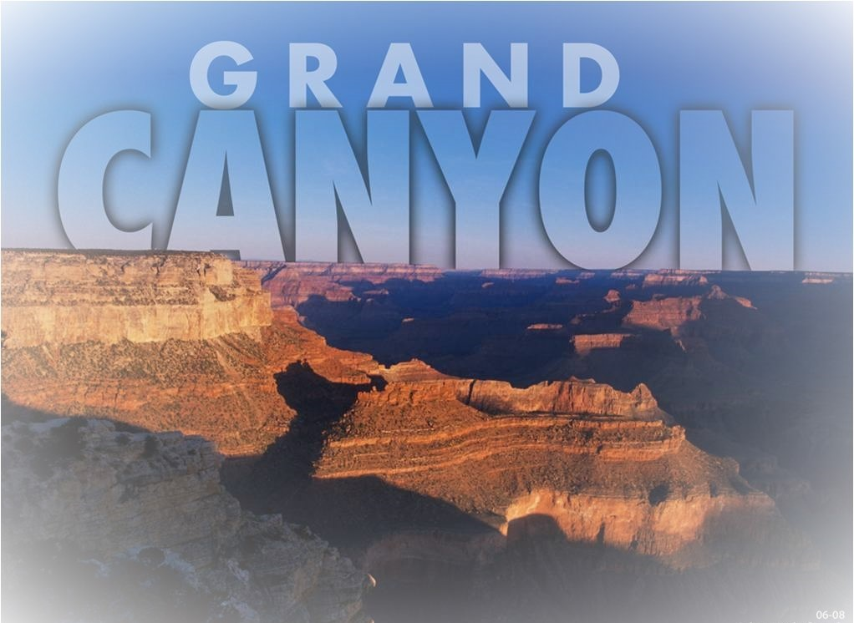

**June 19-22 2025**

**A family friendly trip with Biblical explanations at the rim of the canyon and a 17-mile raft trip!**

**Arrive in Phoenix June 19, depart on June 22**

Join Eric Hovind of Creation Today on this tour along with Helmut Welke of Tennessee Creation Fellowship & Russ Miller of Creation, Evolution & Science Ministries. It’s a fun learning experience.

**The Grand Canyon** is America’s most recognized landmark and one of the top tools used by secularists to support “billions of years” and Darwinism. Spend two full fun-filled days with lectures at the Canyon Rim, some rafting and exploring the area with Eric, Helmut & Russ! You’ll be amazed at the Truth of God’s Word seen at the Grand Canyon area and your faith will be emboldened!

Whether young or old, this is a great Christian Rim Tour of Grand Canyon and an awesome river

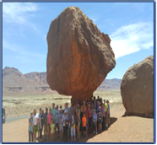raft opportunity to see the Canyon from the bottom up. Bring your family

& friends and experience the Grand Canyon through a Biblical worldview

We book all hotels, meals and tours so you can enjoy a great weekend!

You can fly in and out of Phoenix Sky Harbor Airport (PHX), AZ, for a

four-day, three-night trip. If you fly, you will be responsible for purchasing your own airline ticket. Or incorporate these 4 days into a longer

vacation out west. Leave your vehicle at Hyatt Place, Tempe/Phoenix.

**Please Register by March 15 or sooner to insure a seat. See other side.**

**June 19, 2025 Thursday** Book your flights into Sky Harbor International Airport, Phoenix, AZ where you’ll catch a free shuttle to the Hyatt Place Tempe/ Phoenix Airport Location. **\*Please note:** The Hyatt Place Shuttle does **NOT** pick up at Phoenix-Mesa Gateway airport. If you fly Allegiant Airlines there you will have to arrange for your own transportation to the Hyatt Place Tempe/Phoenix Airport. Check in time is 3PM. Thursday evening dinner is included and you are invited to a 7pm orientation meeting. Your hotel and meals are *included* in the tour price. Drivers to Phoenix can leave their car at the hotel until Sunday.

**June 20, 2025 Friday** After breakfast, a luxury bus will pick us up at the hotel & take us to Grand Canyon, and later to the historic Cameron Trading Post. Breakfast, bus, Park entrance, a picnic lunch, guided tour, dinner and hotel are all included in your tour price. We will spend the night in Page, AZ.

**June 21, 2025 Saturday** After breakfast we will take a half day raft trip down the Colorado River to Historic Lee’s Ferry. This is a quiet float, suitable for ages 4 and up. After lunch we stop briefly to see **Dinosaur** footprints & then return to the Hyatt Place Tempe Airport location. We close with a Pizza Party in the Hyatt Conference Room. Breakfast, raft trip, lunch, bus, dinner and hotel are included in your tour price.

**June 22, 2025 Sunday**: Breakfast at the hotel is *included*. Take the free shuttle to the airport. If you are flying out of Phoenix-Mesa Gateway Airport, you will need to make your own shuttle arrangements.

**To register, print this form & mail in the bottom part with deposit of $300/ person** by March 17, 2025. Note this tour has limited seating. Full payment is due by April 27th 2025.

Or call Helmut Welke at 563-940-5360 to ask questions and to register with credit card.

NOTE: THIS TOUR FILLS FAST. We suggest you get tickets early. **Email: Info@CreationTN.org**

**CANCELLATION POLICY - *Please read.***If you need to cancel, you can do so by April 27, 2025 for a full refund less $25.00 per ticket processing fee. If you cancel between April 27 and May 16, 2025 there will be a $300.00 charge per ticket, with any balance being refunded to you.

**If you cancel May16, 2025 or afterward, no refund is available. But note: Tickets are *transferrable until 6/8*. By paying for your trip, you agree to the cancellation policy.**

**Sign Me Up for the June 19-22, 2025 Creation Grand Canyon Tour & River Raft Trip.**

Name(s)

(Please list all names & ages of children attending, use separate sheet if needed)

Address

City ____State Zip ___ ____

**Email address**

Cell phone ________________________________________ [NOTE: Airfare is NOT included in these prices]

**Prices: Adults: $950.00/person** (double occupancy) Price includes three hotel nights, meals from Thursday evening thru Sunday morning, entrance fee to Grand Canyon, River raft trip, guides, luxury tour bus, bus driver, bottled water, snacks and gratuities. Adults are age 17 and over.

**Single Occupancy: $950.00 plus $240.00** **single occupancy supplement**. ($1,190 total)

**Children: $740.00.00** (Only if staying with 2 paying adults). Children are 16 years of age and under. There is easy walking and optional hiking on this trip. The raft trip is limited to those 4 years old and older.

Adults (double occupancy) # __ ___ x $950.00 = ________________________

Children (with 2 paid adults) # x $740.00 = __ _______________

Single Occupancy____________________ $1,190.00 ($950 plus $240 single supplement for Hotel rooms)

Down payment Check enclosed $_______________________ ( =$300/ person if registering by Mar 17, 2025)

**Mail registration form & check payable to “Welke Intl.” to: CreationTN, 303 Michael Circle, Mt. Juliet, TN 37122 or call Helmut Welke at 563-940-5360 to register with credit card.**